DEEP LEARNING

### A SUMMER TRAINING REPORT

### *Submitted by:*

### VEDANT

### 20BCS6624

*Submitted in the partial fulfillment of summer training for the award of the degree of*

# BACHELOR OF ENGINEERING

**IN**

**ARTIFICIAL INTELLIGENCE AND**

**MACHINE LEARNING**



**APEX INSTITUTE OF TECHNOLOGY**

**CHANDIGARH UNIVERSITY, GHARUAN, MOHALI - 140413,**

**PUNJAB**

**JULY 2022**

**2**. **ABOUT INTERNSHALA TRAININGS**

Internshala is an internship and online training platform, based in [Gurgaon, India](https://en.wikipedia.org/wiki/Gurgaon). Founded by [Sarvesh Agrawal](https://en.wikipedia.org/w/index.php?title=Sarvesh_Agrawal&action=edit&redlink=1" \o "Sarvesh Agrawal (page does not exist)), an [IIT Madras](https://en.wikipedia.org/wiki/IIT_Madras) alumnus, in 2011, the website helps students find [internships](https://en.wikipedia.org/wiki/Internship) with organizations in India.

The platform, founded in 2010, started as a [WordPress](https://en.wikipedia.org/wiki/WordPress) blog that aggregated internships across India and articles on education, technology, and skill gap. Internshala launched its online trainings in 2014. As of 2018, the platform had 3.5 million students and 80,000 companies.

Internshala Trainings are the courses provided by [Internshala](https://www.quora.com/topic/Internshala) where one can learn about your desirable skills.

There are more than 75 courses available right now on [Internshala Trainings](https://www.quora.com/topic/Internshala-Trainings" \o "www.quora.com" \t "_top) like Web Development, Programming in C/C++, Python, ReactJs, NodeJs, Data Structures & Algorithms, IoT, Android Development and many more. There are also few courses outside the computer science domain.

**3. CERTIFICATE**

**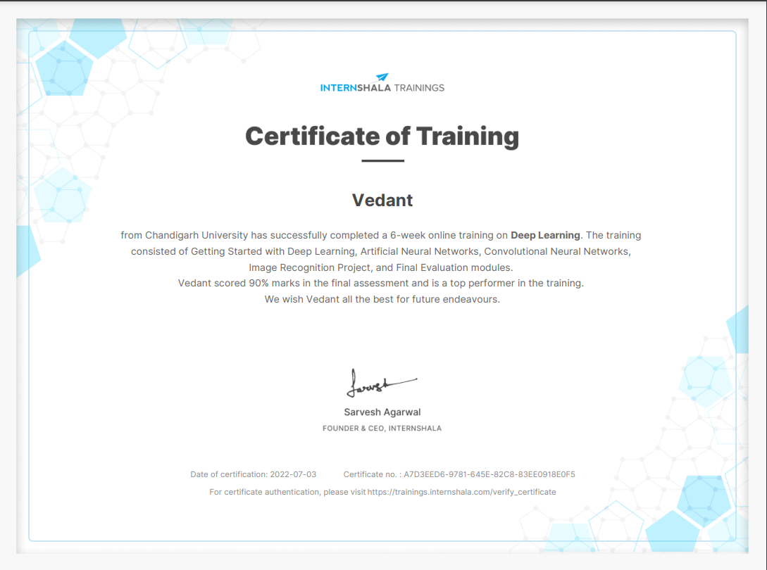**

Link - <https://trainings.internshala.com/s/v/1554099/8a3e3f8f>

**4. ACKNOWLEDGEMENT**

I would like to earnestly acknowledge the sincere efforts and valuable time given by Abhishek Bansal (Co-Founder, Start-Tech Academy) and Pukhraj Parikh (Co-Founder, Start-Tech Academy). Their valuable guidance and feedback have helped us in completing this Deep Learning Course. My sincere efforts finally produced something that I have imagined. I would also like to thank faculty who provided us this golden chance. Last but not least I would like to thank everyone who supported and motivated us for pushing me beyond my strength.

Thank You.

**5. ABSTRACT**

In course named **DEEP LEARNING** by  **INTERNSHALA TRAININGS** , consist of 6 week training module where one can learn new concept related to deep learning and can test his/her knowledge thanks to quizzes and module tests at regular intervals

Week 1 consist of Getting started with Deep learning followed by Artificial Neural Networks then the concepts of Convolutional Neural Networks

Then a hands on experience and great explanation of an Image recognition Project, followed by Final evaluation and Final certification test in week 5-6.

Over that there is the hands-on practice by doing assignments and projects. A big shoutout to 1:1 doubt solving by experts through Q&A forums within 24 hours.

After all this, the student has to attempt a final examination followed by certification.

**6. TABLE OF CONTENTS**

|  |  |  |
| --- | --- | --- |
| **S.No** | **TITLE** | **PAGE No** |
| 1 | Title Page |  |
| 2 | About the Company |  |
| 3 | Certificate |  |
| 4 | Acknowledgement |  |
| 5 | Abstract |  |
| 6 | Table of Contents |  |
| 7 | List of Table/Figures/Photographs |  |
| 8 | About the course/Training |  |
| 9 | Date wise Topics Learnt |  |
| 10 | Outcomes |  |
| 11 | References |  |
| 12 | Appendices |  |

**CHAPTER 1**

**INTRODUCTION**

Deep Learning is a subset of [Machine Learning](https://www.v7labs.com/blog/machine-learning-guide) that uses mathematical functions to map the input to the output. These functions can extract non-redundant information or patterns from the data, which enables them to form a relationship between the input and the output.

This is known as learning, and the process of learning is called training.

In traditional computer programming, input and a set of rules are combined together to get the desired output. In machine learning and deep learning, input and output are correlated to the rules.

These rules—when combined with new input—yield desired results.

**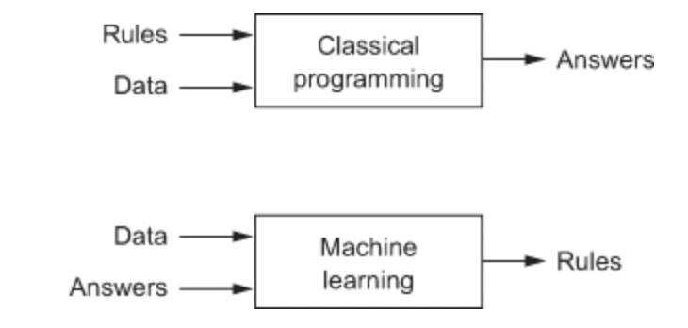**

Modern deep learning models use [artificial neural networks](https://www.v7labs.com/blog/neural-network-architectures-guide) or simply neural networks to extract information.

These neural networks are made up of a simple mathematical function that can be stacked on top of each other and arranged in the form of layers, giving them a sense of depth**,** hence the term *Deep Learning.*

Deep learning can also be thought of as an approach to Artificial Intelligence, a smart combination of hardware and software to solve tasks requiring human intelligence.

**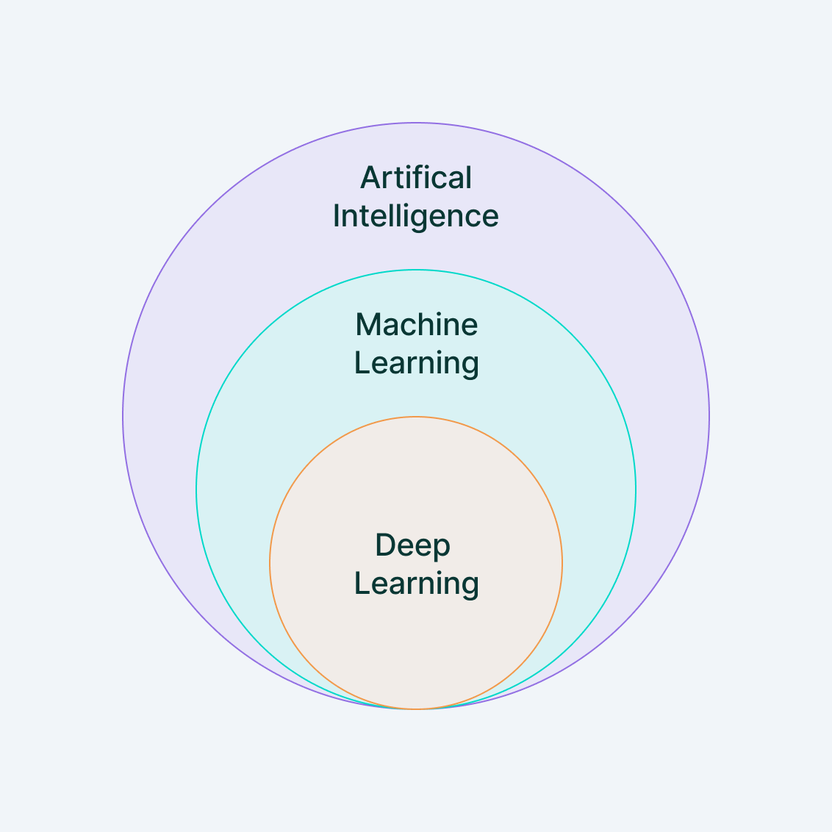**

Deep Learning was first theorized in the 1980s, but it has only become useful recently because:

* It requires large amounts of [labeled data](https://www.v7labs.com/blog/quality-training-data-for-machine-learning-guide)
* It requires significant computational power (high performing GPUs)

**CHAPTER 2**

**NEURAL NETWORKS**

The neural network is the heart of deep learning models, and it was initially designed to mimic the working of the neurons in the human brain.

Here are its components.

**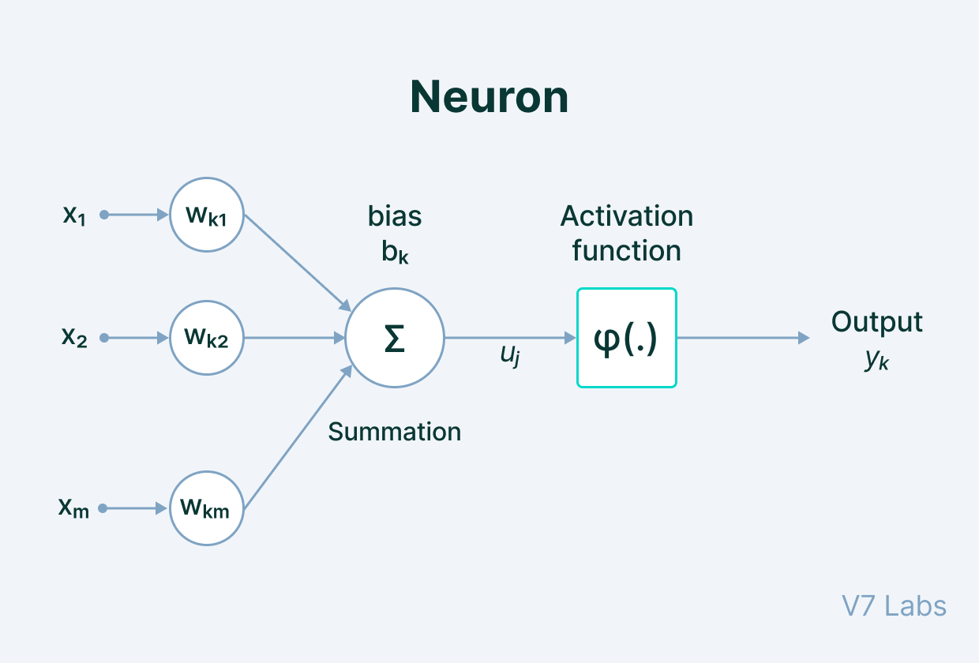**

The neuronal perception of deep learning is generally motivated by two main ideas:

1. It is assumed that the human brain proves that intelligent behavior is possible, and—by reverse engineering, it is possible to build an intelligent system
2. Another perspective is that to understand the working of the human brain and the principles that underlie its intelligence is to build a mathematical model that could shed light on the fundamental scientific questions.

In essence, neural networks enable us to learn the structure of the data or information and help us to understand it by performing tasks such as clustering, classification, regression, or sample generation.

Deep Learning can essentially do everything that machine learning does, but not the other way around.

For instance, machine learning is useful when the dataset is *small* and well-curated, which means that the data is carefully preprocessed.

[Data preprocessing](https://www.v7labs.com/blog/data-preprocessing-guide) requires human intervention. It also means that when the dataset is large and complex, machine learning algorithms will fail to extract information, and it will underfit.

**CHAPTER 3**

**WHY DEEP LEARNING?**

Generally, machine learning is alternatively termed *shallow learning* because it is very effective for smaller datasets.

Deep learning, on the other hand, is extremely powerful when the dataset is large.

It can learn any complex patterns from the data and can draw accurate conclusions on its own. In fact, deep learning is so powerful that it can even process unstructured data—data that is not adequately arranged like text corpus, social media activity, etc.

Furthermore, it can also generate new data samples and find anomalies that machine learning algorithms and human eyes can miss.

**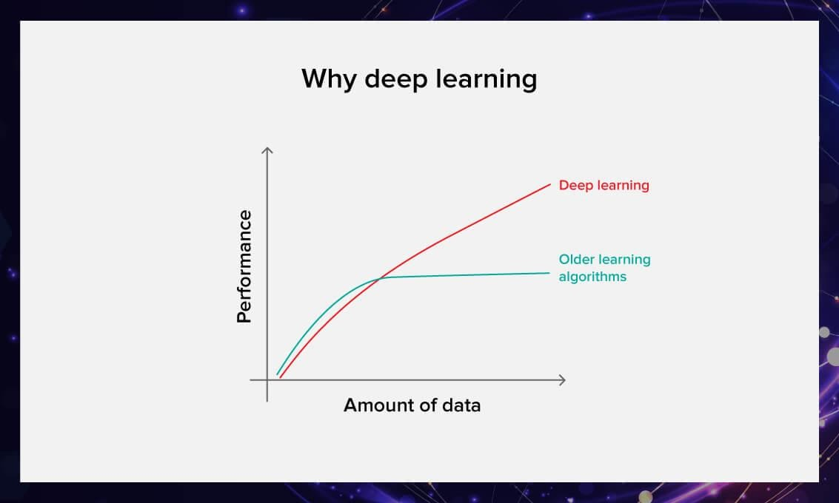**

**CHAPTER 4**

**HOW DEEP LEARNING WORKS**

Deep Neural Networks have multiple layers of interconnected artificial neurons or nodes that are stacked together. Each of these nodes has a simple mathematical function—usually a linear function that performs extraction and mapping of information.

There are three layers to a deep neural network: the input layer, hidden layers, and the output layer.

**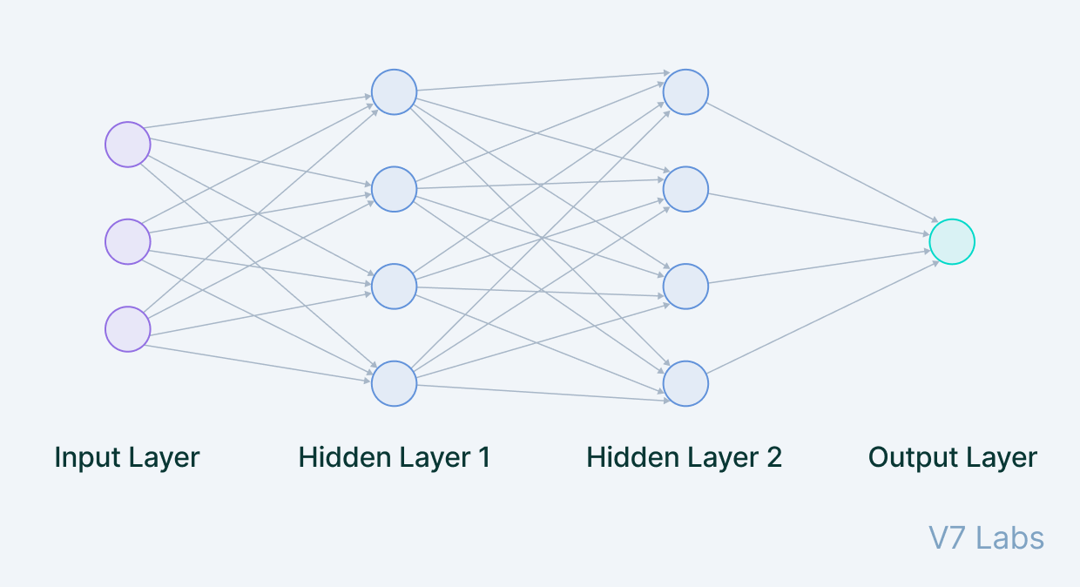**

The data is fed into the input layer.

Each node in the input layer ingests the data and passes it onto the next layer, i.e., the hidden layers. These hidden layers increasingly extract features from the given input layer and transform it using the linear function.

These layers are called hidden layers because the parameters (weights and biases) in each node are unknown; these layers add random parameters to transform the data, each of which yields different output.

**CHAPTER 5**

**TYPES OF NEURAL NETWORKS**

1. **CNN**

[The Convolutional Neural Networks](https://www.v7labs.com/blog/convolutional-neural-networks-guide) or CNNs are primarily used for tasks related to computer vision or image processing.

CNNs are extremely good in modeling spatial data such as 2D or 3D images and videos. They can extract features and patterns within an image, enabling tasks such as [image classification](https://www.v7labs.com/blog/image-classification-guide) or [object detection](https://www.v7labs.com/blog/object-detection-guide).

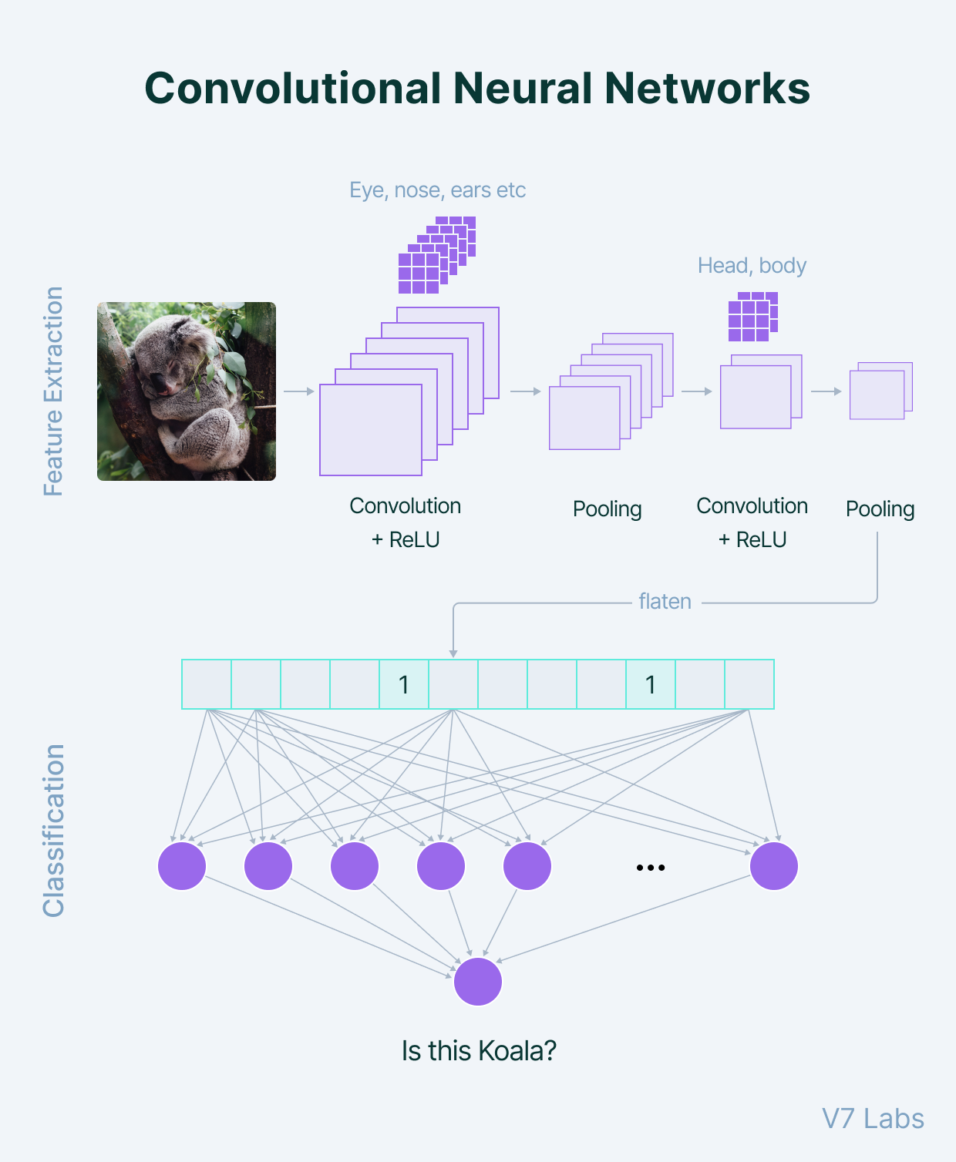

1. **RNN**

The Recurrent Neural Networks or RNN are primarily used to model sequential data, such as text, audio, or any type of data that represents sequence or time. They are often used in tasks related to natural language processing (NLP)

**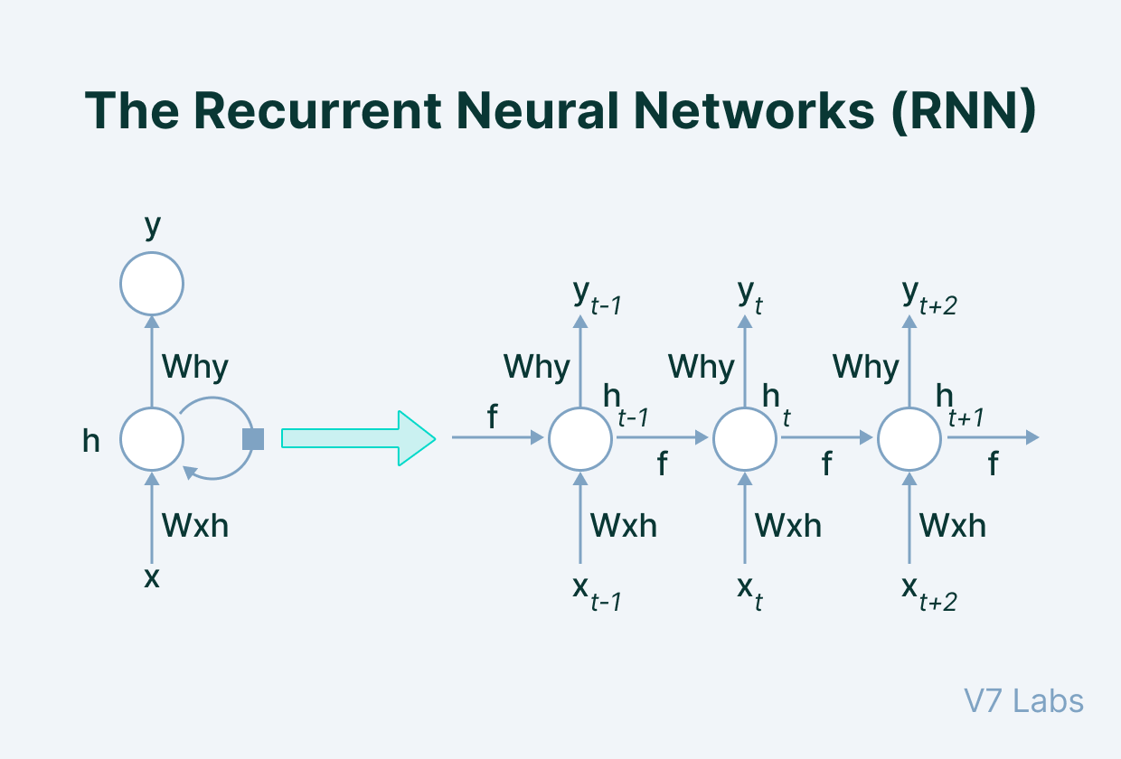**

1. **ANN**

The term "Artificial neural network" refers to a biologically inspired sub-field of artificial intelligence modeled after the brain. An Artificial neural network is usually a computational network based on biological neural networks that construct the structure of the human brain. Similar to a human brain has neurons interconnected to each other, artificial neural networks also have neurons that are linked to each other in various layers of the networks. These neurons are known as nodes.

Artificial neural network tutorial covers all the aspects related to the artificial neural network. In this tutorial, we will discuss ANNs, Adaptive resonance theory, Kohonen self-organizing map, Building blocks, unsupervised learning, Genetic algorithm, etc.

**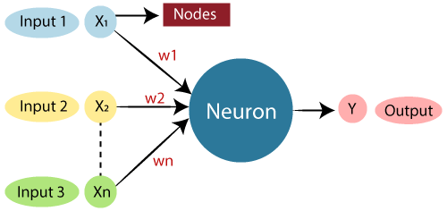**

**CHAPTER 6**

**TRANSFER LEARNING**

[Transfer learning](https://www.v7labs.com/blog/transfer-learning-guide) is an approach*w*here you use an existing pre-trained model and fine-tune it with your desired dataset. This is the most common approach.

Networks such as AlexNet or GoogLeNet, VGG16, and VGG19 are some of the most common pre-trained networks.

Transfer learning has advantages over training a model from scratch because:

a) You don’t need to design an entire architecture from scratch.

b) The training time is shorter.

c) You can train with less data.

**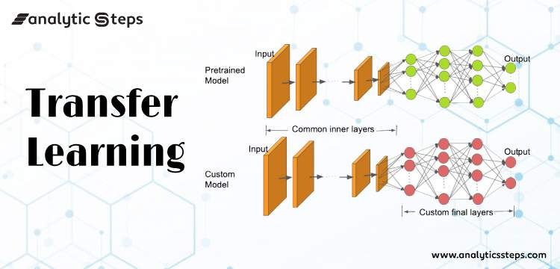**

**CHAPTER 7**

**HANDS ON IMAGE RECOGNITION PROJECT**

The [MNIST dataset](https://en.wikipedia.org/wiki/MNIST_database) is an acronym that stands for the Modified National Institute of Standards and Technology dataset.

It is a dataset of 60,000 small square 28×28 pixel grayscale images of handwritten single digits between 0 and 9.

The task is to classify a given image of a handwritten digit into one of 10 classes representing integer values from 0 to 9, inclusively.

It is a widely used and deeply understood dataset and, for the most part, is “solved.” Top-performing models are deep learning convolutional neural networks that achieve a classification accuracy of above 99%, with an error rate between 0.4 %and 0.2% on the hold out test dataset.

**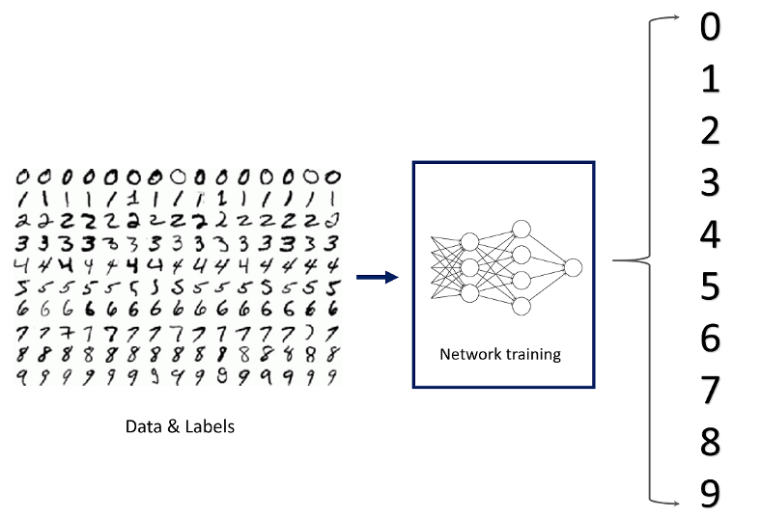**

**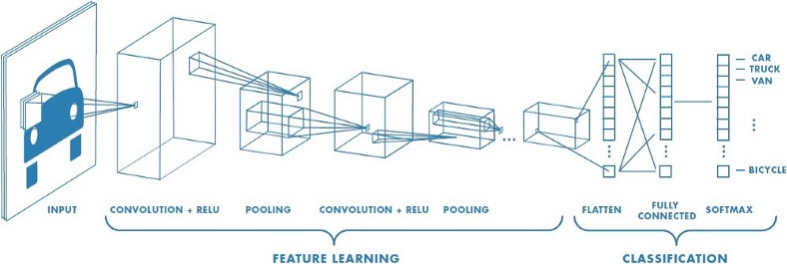**

****

**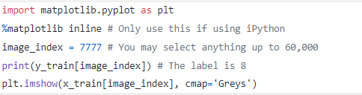**

**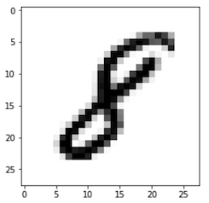**

**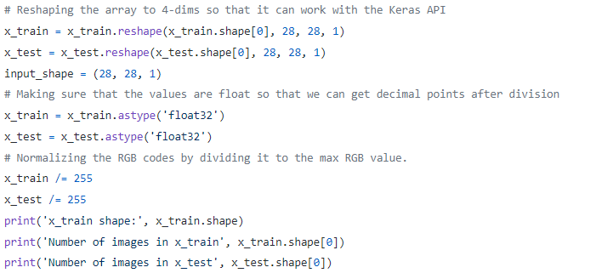**

# Building the Convolutional Neural Network

We will build our model by using high-level Keras API which uses either TensorFlow or Theano on the backend. I would like to mention that there are several high-level TensorFlow APIs such as Layers, Keras, and Estimators which helps us create neural networks with high-level knowledge. However, this may lead to confusion since they all vary in their implementation structure. Therefore, if you see completely different codes for the same neural network although they all use TensorFlow, this is why. I will use the most straightforward API which is Keras. Therefore, I will import the Sequential Model from Keras and add Conv2D, MaxPooling, Flatten, Dropout, and Dense layers. I have already talked about Conv2D, Maxpooling, and Dense layers. In addition, Dropout layers fight with the overfitting by disregarding some of the neurons while training while Flatten layers flatten 2D arrays to 1D arrays before building the fully connected layers.

**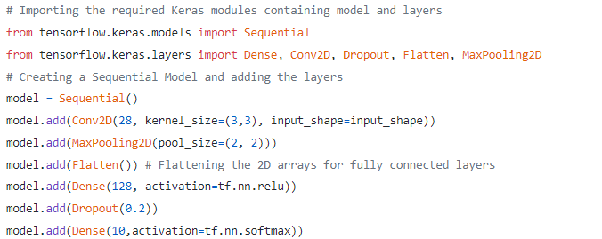**

**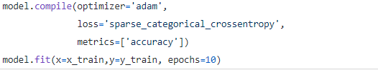**

****

**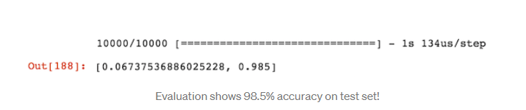**

**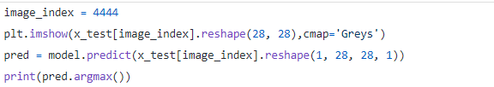**

**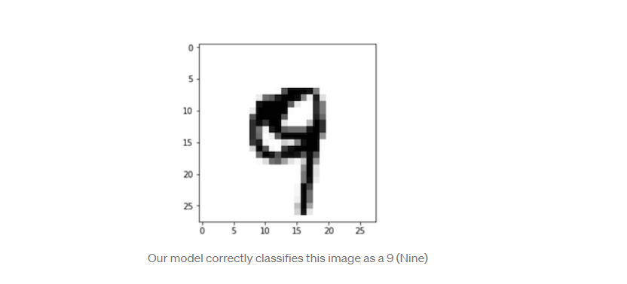**

**DATE WISE TOPIC LEARNT**

**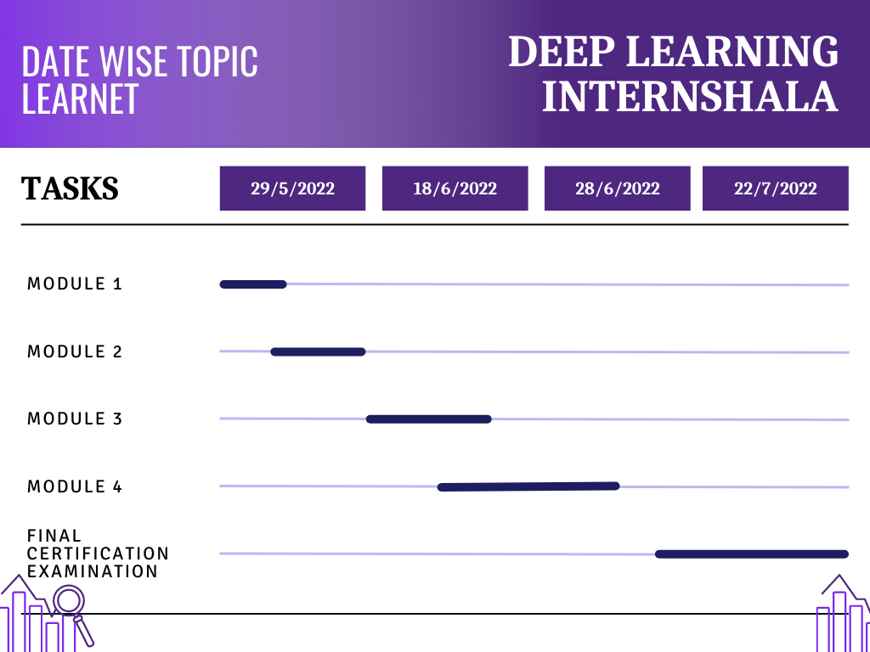**

**OUTCOME**

After learning DEEP LEARNING from INTERNSHALA TRAININGS, I was able to understand how deep learning and different types of neural networks works. I was able to use transfer learning and the knowledge gained by this course into making a useful project based on DEEP LEARNING

I have successfully made a project named FACE MASK DETECTION using the concepts of transfer learning and using VGG19.

Below a brief look into project

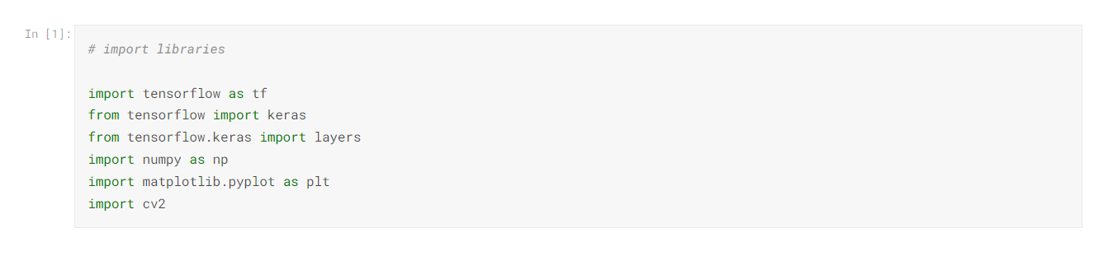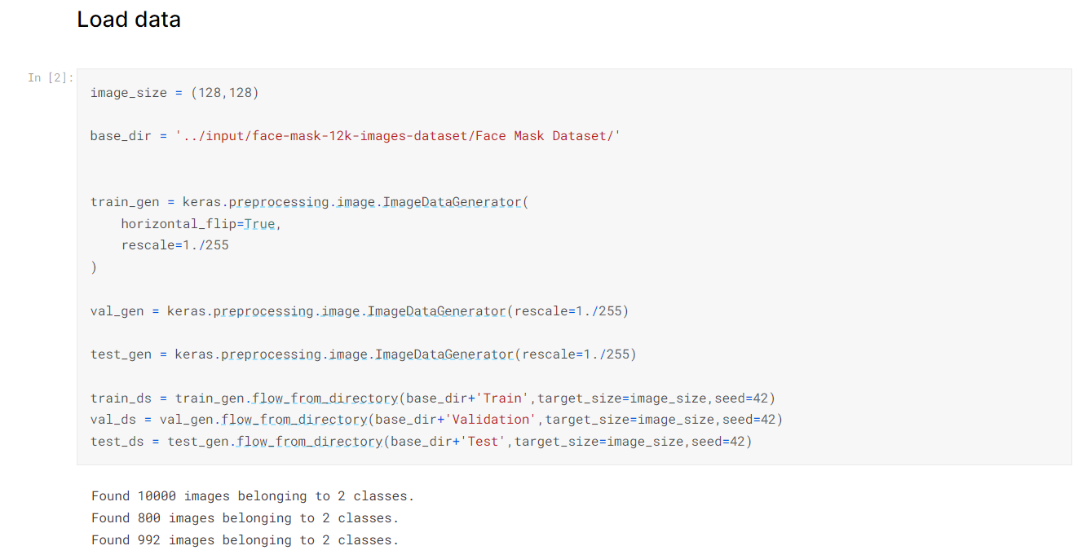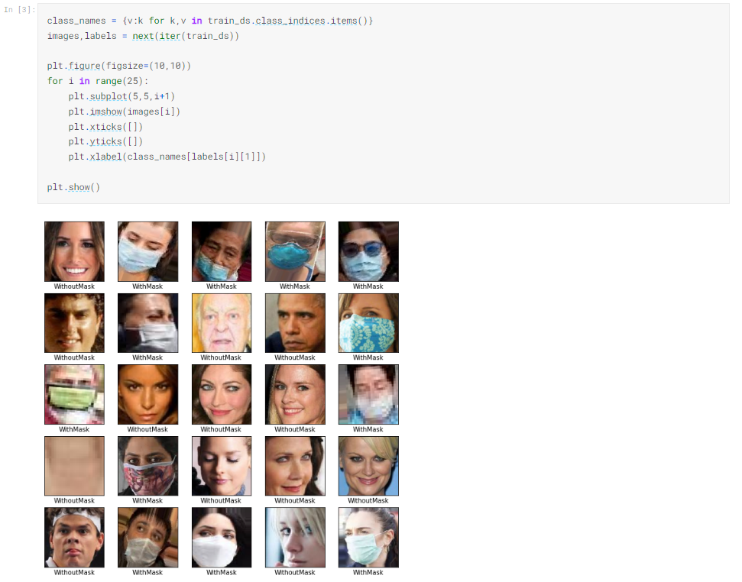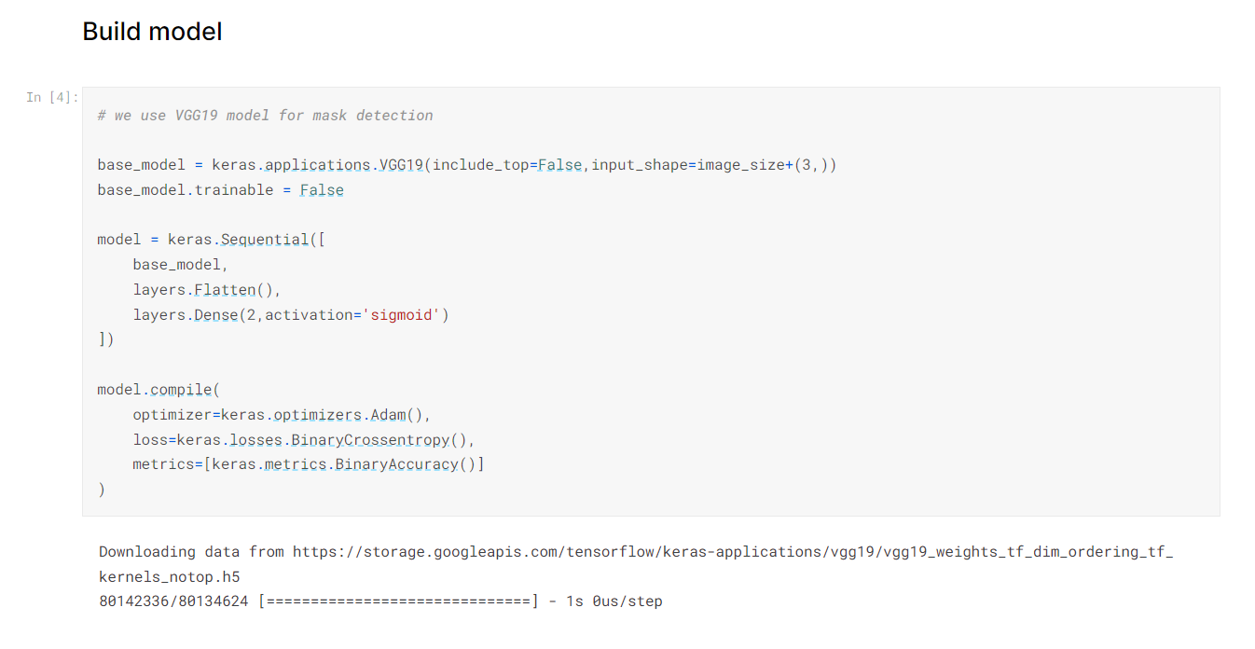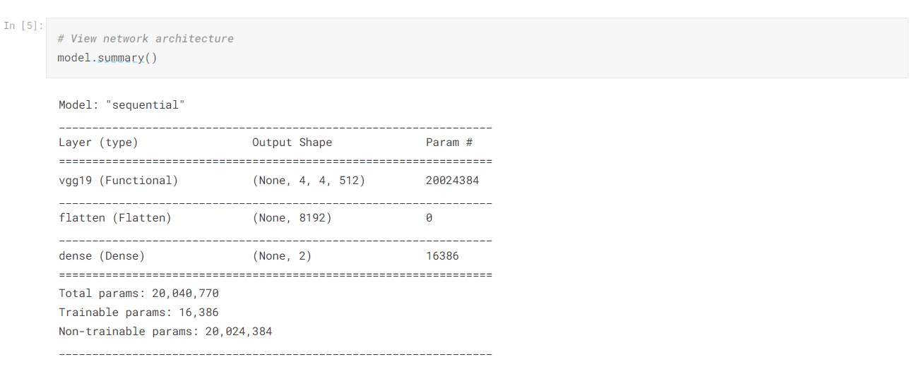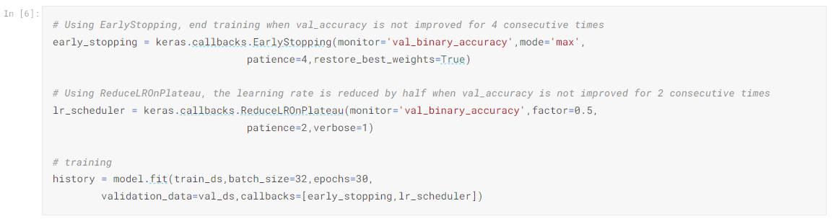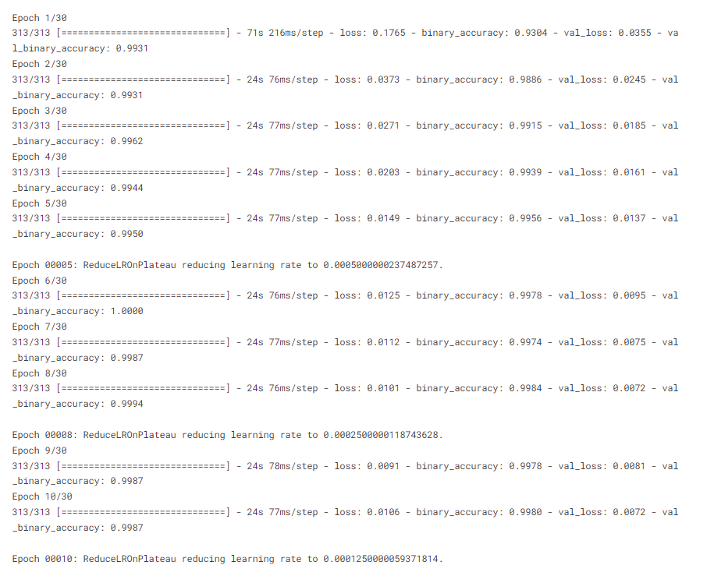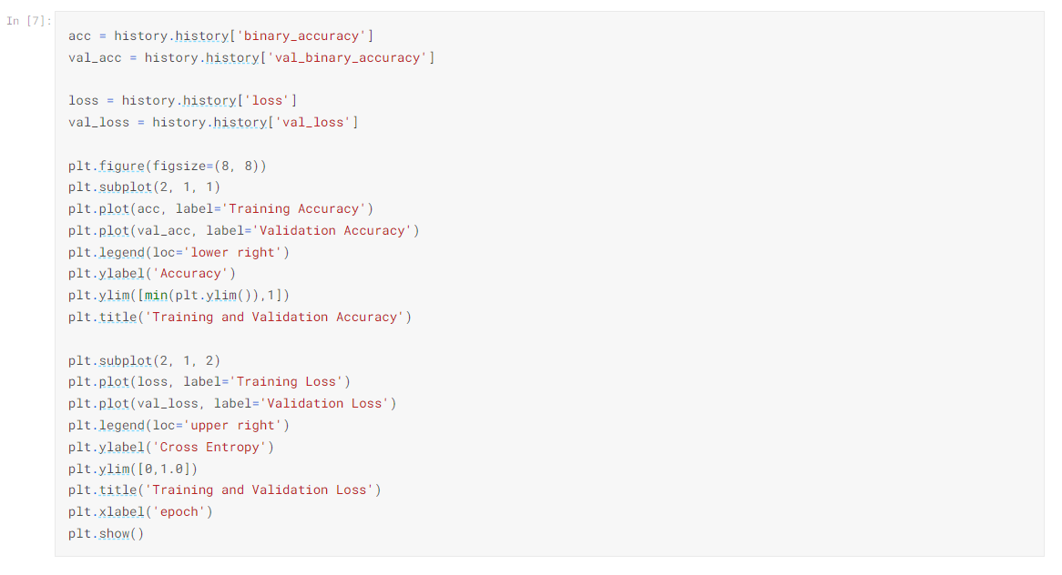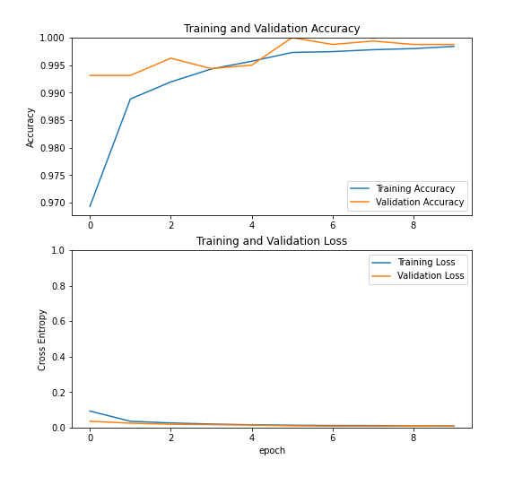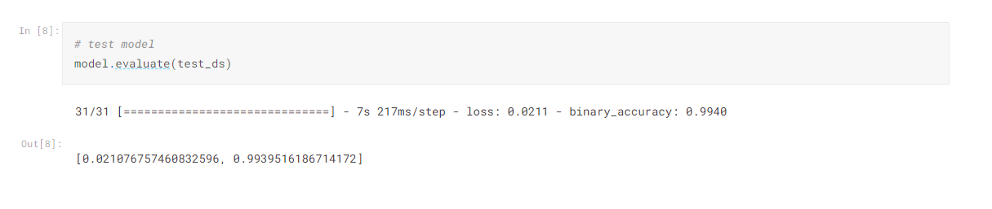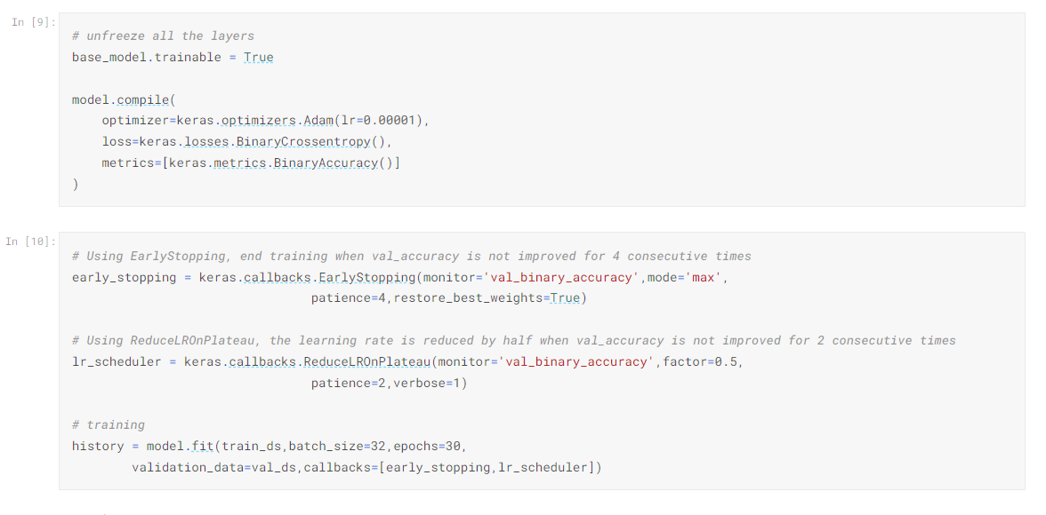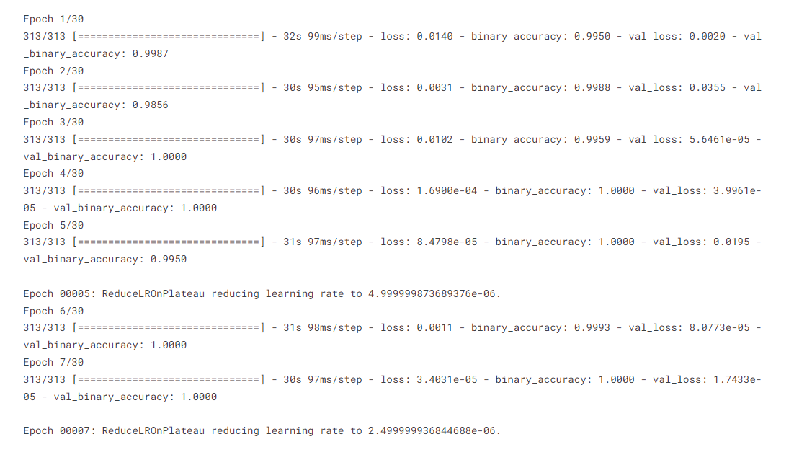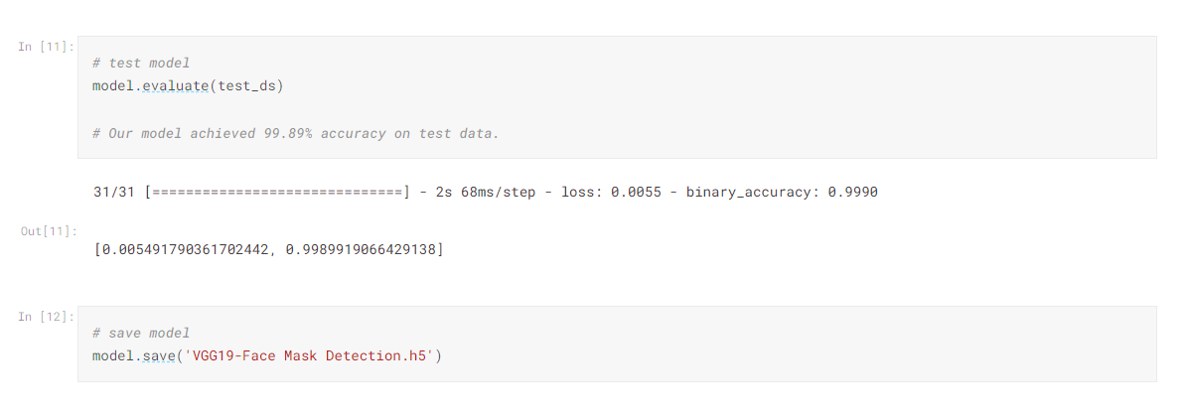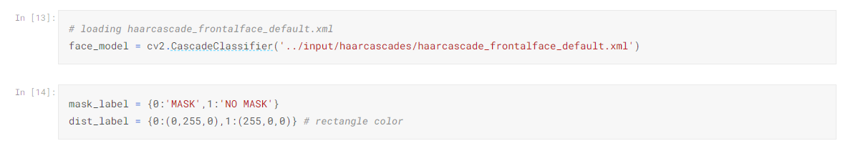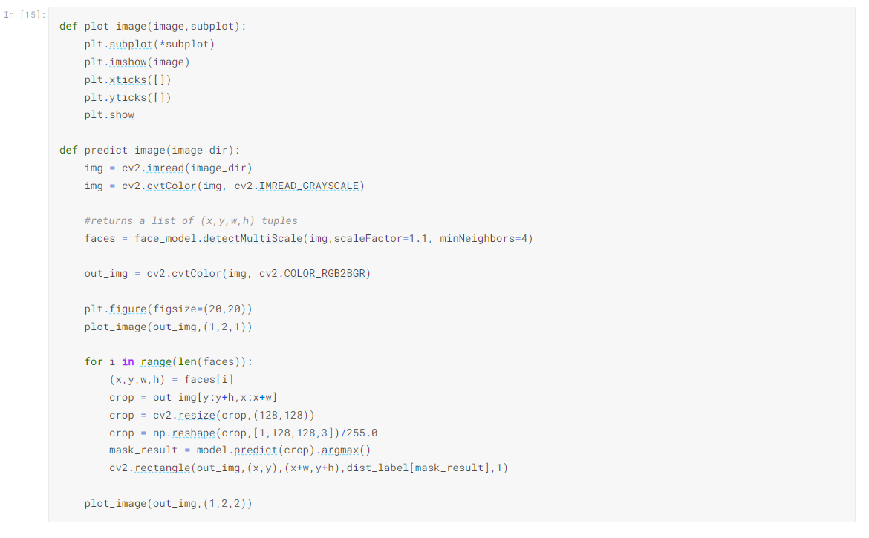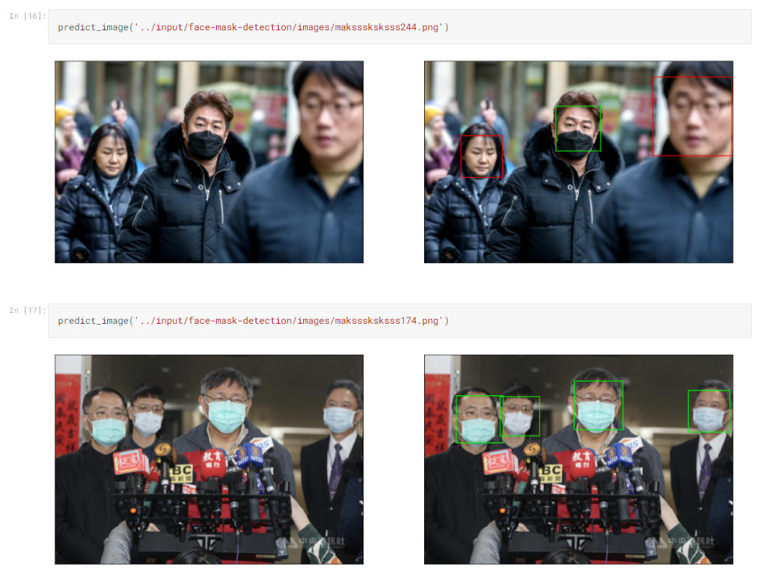

**CONCLUSION**

I believe that I have shown conclusively that it is both possible and desirable to use deep learning concepts in making something useful for society in these hard pandemic times.

**FUTURE SCOPE**

The topic DEEP LEARNING is a continuously expanding and burning topic of today’s scenario and I personally believe that in coming times this area will be more explored and various new and efficient techniques can be implemented or some new ways can be invented to make use of machine learning.

**REFERENCES**

[**https://www.v7labs.com/blog/deep-learning-guide**](https://www.v7labs.com/blog/deep-learning-guide)

[**https://towardsdatascience.com/image-classification-in-10-minutes-with-mnist-dataset**](https://towardsdatascience.com/image-classification-in-10-minutes-with-mnist-dataset)

[**https://www.analyticsvidhya.com/blog/2021/10/understanding-transfer-learning-for-deep-learning/**](https://www.analyticsvidhya.com/blog/2021/10/understanding-transfer-learning-for-deep-learning/)